**Kingsmills PS - November Newsletter 2021**

Breakfast Club

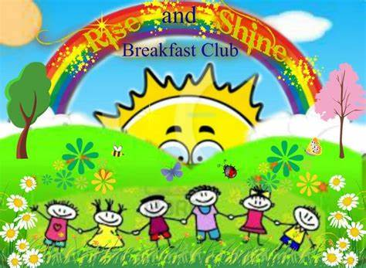Our Breakfast Club continues each morning from 7:30am. Please use booking forms (these can be downloaded form the school website) and pre book your slots on a Friday for the following week.

## Shoebox Appeal

Mrs Ruth Agnew took assembly on 13th October to launch the shoebox appeal. All shoe boxes should be returned to school for Friday 12th November for collection on Monday 15th November.

Many thanks for your support with the appeal.

## Parent Teacher Meetings

MC900056113[1]Parent Teacher meetings will take place on Monday 1st November- Wednesday 3rd November.

**All children will be going home at 1.15pm on these days**. **Please collect your child promptly.**

**Compass North**

Fitness coach Nicola Sloan will be back in school on Wednesday 3rd November so the children can continue to enjoy fitness and dance classes. She will be with us for 6 weeks. Please wear P.E kit on these days.

**After School Clubs**

**Attendance at after school clubs will be dependent on good behaviour. Any child misbehaving or causing a disruption will not be allowed to attend.**

**Monday:**

Minecraft Club: P3-7 from 2.30pm- 3.30pm. It will be running for 4 weeks from Monday 8th November.

**Tuesday**:

****Football with Healthy Kidz

P1/2 – 1.15- 2.15pm

P3-7- 2.30-3.30pm and will be running for 6 weeks until Tuesday 14th December.

**Wednesday**:

Games Club – P1/2 - 1.15pm- 2.15pm. The after school club will be running until Wednesday 17th November

**Thursday**:

Hockey P3-7 - 2.30pm- 3.30pm. Hockey club will be running until

Thursday 11th November

**Friday:**

Debutkids: P1/2- 1.15- 2.15. P3-7: 2.30pm-30pm. It will be continuing until Friday 10th December

**Remembrance Service**

A Remembrance Service will take place in Bessbrook on Sunday 14th November. A wreath will be laid by representatives from the school.

[](https://www.google.co.uk/imgres?imgurl=http://clipartandscrap.com/wp-content/uploads/2017/06/Clipart-coins-3.png&imgrefurl=http://clipartandscrap.com/coin-clip-art_8169/&docid=04c7pHzHJlazsM&tbnid=7akm-IbFvjXyoM:&vet=10ahUKEwja7uaVq47XAhWGD8AKHbQnCJUQMwidAihFMEU..i&w=2080&h=2560&hl=en&safe=active&bih=986&biw=1920&q=cartoon%20coins&ved=0ahUKEwja7uaVq47XAhWGD8AKHbQnCJUQMwidAihFMEU&iact=mrc&uact=8)**Christmas Play**

This Christmas we are hoping to have a Christmas Play. We will confirm the exact date with you as soon as we can.

**Ulster Museum Trip**

The P3-5 will be heading to the Ulster Museum to further extend their knowledge of dinosaurs. The children will be leaving school at 8.45am and be retuning for 2.45pm. Please send a healthy packed lunch and snacks on this day. I know the children are looking forward to learning and seeing lots of new things!!

**NI Water**

Representatives from Northern Ireland Water will be coming to school to talk to the FS children about the importance of water. This links to our Eco School targets and helps the children fulfil their action plan objectives

**Music Lessons**

Fiddle lessons will be continuing with Keith every Wednesday afternoon and piano will be continuing with Kerry every Monday morning.

**School Website and Facebook Page**

Please log on to our school website at [www.kingsmillsps.co.uk](http://www.kingsmillsps.co.uk) and check out our Facebook page. These media will keep you updated with all school activities and events.

School ClosuresMC900232103[1]

If school has to close due to adverse weather, it will be announced through our website [www.kingsmillsps.co.uk](http://www.kingsmillsps.co.uk) and we will contact parents by our text messaging service or our Facebook page. Information for parents regarding reasons for school closures, such as weather, electricity failure etc. is available on the NI Direct website at [www.education-ni.govuk/publications/checklist-exceptionaol-closure-schools](http://www.education-ni.govuk/publications/checklist-exceptionaol-closure-schools)

**Coats/Hats/Gloves**

As the weather continues to get colder, please ensure your child brings and wears suitable winter clothing to school. Please ensure their name is clearly marked on their belongings.

**Dinner/Snack Money**

Please send all dinner money and snack money (P1 - P5) on Monday morning. **To aid the process please ensure you send the correct change.**

Many thanks,

G Harrison