Kingsmills Primary School

Newsletter – October 2019

**Thank You**

I would like to thank all those who were involved in completing any tasks around the school grounds in preparation for this school year and for all those involved in the preparation of the ground and delivery of our new container. Your efforts are greatly appreciated. Teamwork at its best!

**Macmillan Coffee Afternoon**

Thank you to all those who helped organise, provide food and who

came along to our

Macmillan Coffee Afternoon.

A total of £275.16 was raised for this charity.

Breakfast Club

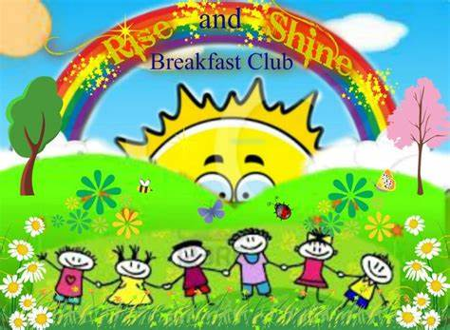Our Breakfast Club continues each morning from 7:30am. Please book your child’s place using the booking forms provided. Breakfast club can be booked weekly or in block for your convenience.

**Swimming**

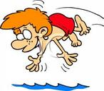Swimming lessons will continue for P5-7. Our dates for the remainder of this half-term are: 1st and 15th October.

Please continue to send a packed lunch on these days as the children will need to leave school before school dinners are served. Swimming lessons and buses are paid for by the school.

**Harvest Assembly**

[](http://www.google.co.uk/imgres?imgurl=http://images.clipartpanda.com/harvest-clipart-RTG5B4kTL.gif&imgrefurl=http://www.clipartpanda.com/categories/harvest-20clipart&h=420&w=490&tbnid=iuiZ_wqeZmh-4M:&zoom=1&docid=5_6bRWTRvNalvM&hl=en&ei=r20yVJWfA8Su7AaX5YGIBw&tbm=isch&ved=0CCMQMygbMBs4ZA&iact=rc&uact=3&dur=753&page=9&start=124&ndsp=16)Our Harvest Assembly will be held on Thursday 10th October at 10:00am in the school hall.

All parents and family members are most welcome to join with us. All the pupils will be taking part. We hope to see you all there.

**To facilitate staff development, all pupils will go home after the Harvest assembly. No dinners will be served that day.**

**Kingmills Kiddies**

Our baby and toddler group Kingsmills Kiddies continues every Friday morning in the Assembly Hall from 10 to 11.30am. Our thanks go to Ms Rebekah Riddle and Mrs Sharon McIlveen who have kindly agreed to share the running of this group.

**School Website and Facebook Page**

Please log on to our school website at [www.kingsmillsps.co.uk](http://www.kingsmillsps.co.uk) and check out our Facebook page. These media will keep you updated with all school activities and events.

#### Holiday Reminder

School will be closed from Monday 28th October – Friday 1st November for half term break. These dates are inclusive. Friday 25th October will be a non-uniform day for pupils.

**Music Lessons**

Keith Lyttle, our fiddle and tin whistle tutor will continue lessons every Wednesday and Kerry Ramsey our piano tutor will continue piano lessons every Thursday.

**After School Activities:**

Football:

* P1/2 - 1.15pm- 2.15pm
* P3-7 - 2.30pm - 3.30pm with the final session taking place on Tuesday 15th October.

Tag-Rugby:

* P1/2 - 1.15pm- 2.15pm
* P3-7 - 2.30pm - 3.30pm with the final session taking place on Wednesday 16th October.

Hockey Club:

* P5-7 - 2.30pm- 3.30pm with the final session taking place on Thursday 17th October.

School Council

The children have elected their School Councillors for this year. They are:



P2 – Eve and Adam

P3 – Emily and Oliver

P4 – Finley

P5 – Rossi and Joel

P6 – Ruby and Charlotte

P7 – Robyn and Sophie

Best wishes to our Councillors. We look forward to hearing their ideas. They have their own budget to manage, so spend it wisely! ☺

## Parent Teacher Meetings

MC900056113[1]Parent Teacher meetings will take place on Monday 21st October- Wednesday 23rd October.

**All children will go home at 1:15pm on these days.**

Appointment arrangements will follow shortly.

**Shared Education**

Our Shared Education Program is now underway for this year. On Wednesday 23rd October P3/4 will be going to Mullaglass PS for a Sentinus activity and P5/6/7 will be visiting Bessbrook and the Egyptian Arch to learn about the history in the area. On Thursday 24th October P1/2 will be visiting Mullaglass PS for Literacy through Outdoor Play.

**Sport for Champions UK**

On Thursday 7th November a Team GB athlete will be visiting school. He will speak to the pupils and pupils will take part in circuits under his leadership. Pupils will be issued with sponsor forms soon in order to be sponsored for completing the circuits. This is a unique opportunity for Kingsmills Primary School and we are very excited to have the opportunity to meet a champion! Further details will follow.

**School Nurse**

The school nurse will be in school on Monday 25th November to administer the flu vaccination.

**Coats/Hats/Gloves**

As the weather continues to get colder, please ensure your child brings and wears suitable winter clothing to school. **Please ensure their name is clearly marked on all their belongings.**

**Patchwork Classes**

Patchwork classes will continue (fortnightly) on a Tuesday from 7pm - 9pm. (Next sessions on Tuesday 8th and 22nd October)

Come along and join in the fun!!!

Many thanks for your continued support.

H. Wright (Acting Principal)