**Kingsmills**

**Primary School**



**Supporting your Child with Numeracy at Home**

**Oct 21**

**General Homework Tips**

1. Pupils need an environment free from distractions e.g. T.V, tablets etc.
2. Establish a routine: Do homework at a certain time every afternoon/evening.
3. Encourage and support your child. Praise them on previous homeworks and when they have made an effort.
4. Avoid confrontation. If a child genuinely cannot do something make a little note for the teacher on the page or cover sheet of their homework.
5. Parents should show a genuine interest in their child’s work.
6. Make sure that homework is being taken down properly (in KS2). This is a technique that children are taught but regularly need reminding off.
7. Check and sign children’s work. Make sure it’s correct and that the presentation is acceptable.
8. The time your child spends on their homework should increase as they progress through the school. However, your child should not be spending hours on their homework. If this is the case, please let your child’s teacher know that they are struggling.
9. Learning homeworks (non-written) are sent home on various occasions especially when there is a school production. These are perfectly legitimate and need to be done thoroughly.
10. In P1-P5 all homeworks are sent home at the beginning of each week. This is to give pupils more time to complete homeworks. However, please bear in mind that each homework is based on what has been covered in class that day. Therefore, as much as possible, encourage your child to complete one homework per night.

**Supporting your child with Numeracy in FS/KS1**

In Foundation Stage and Key One the focus is on **mental maths** and **developing mental strategies.** Pupils in Foundation Stage and Key Stage One will also be encouraged to use **practical resources** to help them e.g. cubes, counters, number lines, 100 squares etc. By the end of P4 pupils will be moving towards standardised written methods but **these will not be introduced properly until P5.**

Below are some of the methods used for addition/subtraction and multiplication/division. This will give you an understanding of how to help when a number homework comes home.

**Addition**

1. ***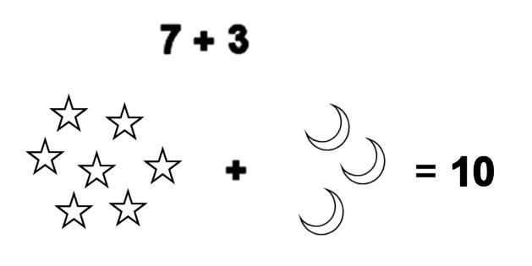*Practical activities using pictures and practical resources (e.g. counters, blocks).****
2. **Partitioning 14 → 10 + 4 (14 splits to 10 and 4)**

Arrow Cards are used in school to partition: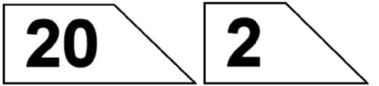

22 splits to give 20 and 2

1. **Using number line/ tracks for addition:**

14 + 3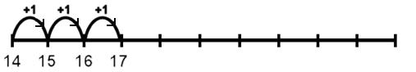

Start at 14, jump on in ‘ones’ three times

So the answer is 17

1. 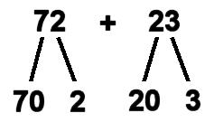**Horizontal addition**

E.g.: 72 + 23

(70 + 20) + (2 + 3)

90 + 5 = 95

1. **Using number line for TU + TU**

72 + 23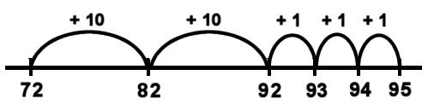

Start at 72 – Jump forward in ‘tens’ twice (23=20+3) then jump forward in ‘ones’ three times.

**Subtraction**

1. **Practical activities using objects (e.g. counters/blocks)**

****7 – 3 = 4



1. **Using a number line for 7 – 3 (starting with a printed number line, then moving to a blank one)**

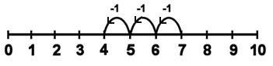

Start at 7, jump back in ‘ones’ three times 7 – 3 = 4

1. **Using number line for TU – U**

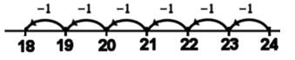



1. **Subtraction as finding the difference (demonstrate using practical resources).**

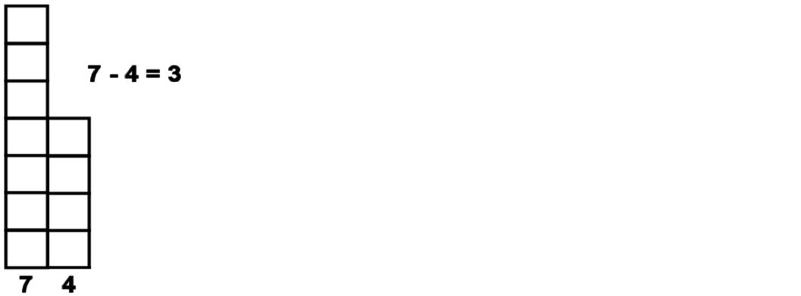

1. **Partitioning 73 – 21**

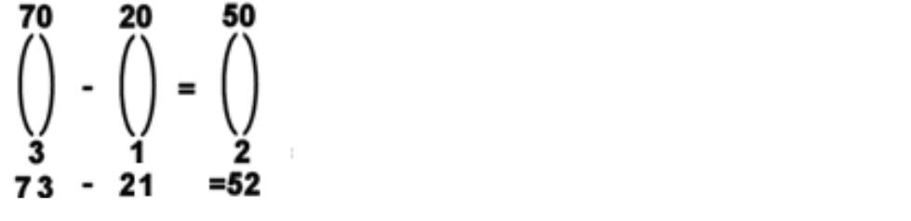

Subtract the tens 70 – 20 = 50

Then the units 3 – 1 = 2

So the answer is 52

1. **Number line 73 – 21**



73 – 21 = 52

Start at 73 – Jump back in ‘tens’ twice. Then jump back in ‘ones’ once.

1. 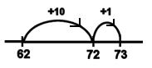 **Subtraction as finding the difference**

Start at 62. Jump 10 to 72 then 1 unit to 73.

Total jumps = 10 + 1 = 11

**Multiplication**

1. **Sequences – counting aloud in jumps of 2 or 5.**

2, 4, 6, 8, 10 ….

5, 10, 15, 20, 25 …. 10, 20, 30, 40 ….

1. **Repeated addition using hands or apparatus or diagrams.**

3 x 5

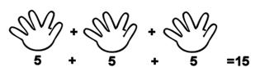

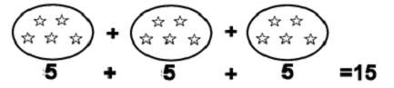

1. **Using a number line for jumps of 2, 3 and 5.**



5 x 2 = 10

1. **Arrays**

3 x 5 5 x 3



1. rows of 5 or 5 rows of
2. **Continuing to use Number lines**

4 Jumps of 5

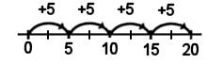

4

4 x 5 = 20

**Division**

1. **Practical activities using resources**

Share 10 sweets between 2 children

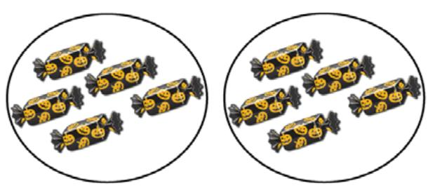

Each child has 5 sweets.

How many groups of 5 bananas could you make with 10 bananas?

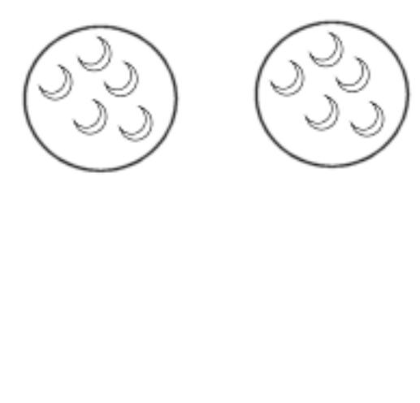

= 2 groups

1. **Division using a number line (repeated subtraction)**

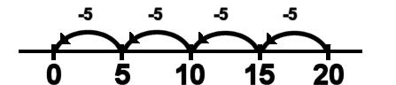

20 ÷ 5 =

Start at 20

Jump back in 5s to 0

The number of jumps gives the answer – 4 jumps

20 ÷ 5 = 4

1. **With remainders - Sharing using practical apparatus**

Share 14 cubes between 4 children

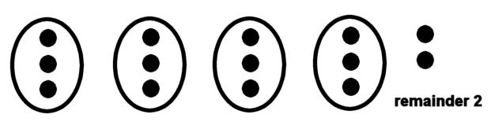

Each person gets 3 cubes and there are 2 left over.

14 ÷ 4 = 3 remainder 2

**What can you do at home?**

* Use practical resources when completing homework (particularly in FS) e.g. counters, coins etc.
* As your child progresses to KS1 (P3/4) they may want to move from using practical resources to using their fingers to help them keep track e.g. when counting in 5s etc.
* Encourage your child to explain/show you the method that they have been using in school.
* Read the instructions on the cover page of your child’s homework, explaining how to complete the maths activity.
* Make Numeracy fun! Play Numeracy games, that aren’t part of your child’s homework e.g. quick fire times tables in the car (P3/4), matching and sorting socks from the tumble dryer/washing line (P1/2) etc.
* Get your child to play Numeracy games on an iPad/laptop/computer (see websites below)
* Be positive about Numeracy! Avoid statements like ‘I was no good at maths at school’ or ‘maths is hard’ etc.
* Use a variety of language when practicing sums e.g. don’t always say 2 add 3; Vary it by saying 2 plus 3, 2 increased by 3, 3 more than 2 etc.

Below are a list of websites with games suitable for FS/KS1:

* [www.topmarks.co.uk](http://www.topmarks.co.uk) (choose the appropriate age for your child)
* [www.mathsframe.co.uk](http://www.mathsframe.co.uk)
* [www.rmeasimaths.co.uk](http://www.rmeasimaths.co.uk) (use child’s login and password details from school)
* [www.ICTgames.co.uk/Numeracy](http://www.ICTgames.co.uk/Numeracy)

You may also find this website contains helpful videos/guides for different topics:

* www.bbc.co.uk/bitesize/subjects/zjxhfg8

**Key Stage Two (P5-7)**

In Key Stage Two the focus is also on mental calculations as we believe that mental methods are the quickest and most efficient way to complete a sum. However all children have different mental capabilities. We therefore also teach written methods of calculation, ensuring that the needs of all children are met within any given class.

Outlined below are the strategies we use in school to teach number. This will give you an understanding of how to help when a number homework comes home. The following topics are addressed:-

* 6 mental strategies
* Decomposition- written subtraction
* Borrow and exchange - written addition

1. **Rounding and Adjusting**

This is a way of adding or subtracting numbers when one of then ends in 1 or 2 or 9.

Take the number that ends in 1,2, 8 or 9 and change it to the nearest 10 or multiple of 10.

If you add a number at the start, then you must subtract it at the end:

* 34+9 + 34+10 =44 44-1 =43

34 +10 = 44 44-1 = 43

If you subtract a number at the start then you must add it at the end:

* 70 - 8 = 70 -10 +2

1. -10 =60 60 +2 = 62
2. **Bridging (Counting on)**

You can make it easier to use numbers if you work out what should be added or taken away to bring you to a 10 or a multiple of ten.

Then add or subtract the other number separately.

* 6+7 = 6+4+3 =10+3 =13

6 +4 =10 10+3 =13

* 23-9 = 23-3-6 =20-6 =14

23 -3 =20 20 - 6 =14

* 49+32 = 49+1+31 = 50+31= 81

49+1 = 50 50 +31 = 81

* 5.6+3.5 = 5.6=0.4+3.1 = 6.0+3.1

5.6+0.4 6.0 6.0+3.1 = 9.1

**3. Adding/Removing ‘0’s**

When a number is a multiple of 10, 100, 1000, 10,000 etc… We can make it easier to work with by adding and taking of our 0’s.

We must remember that if we take the 0’s off, **we have to add them back on and we must be careful to add on the exact number of 0’s taken off.**

* 100 + 400 1+4 = 5 5 +00 = 500
* 1100 + 1300 11+13 = 24 24 +00 = 2400

* 20 x 50 2 x 5 = 10 10+ 00= 1000
* 90 x 600 9 x 6 = 54 54 + 000 = 54 00

**4. Partitioning**

This is when we break the numbers in small parts in order to add/subtract them more easily.

The examples below will explain the process:

When adding the number 234 + 312.

We can group the numbers into smaller parts

e.g. 234 + 312 200+300 and 34 + 12

2+3 = 5 and 34+12 = 46 = 546

e.g. 497 + 345 400 + 300 = 700 and 97+45 = 152 700 + 152 = 852

**5.Hundreds, tens and units**

We can add/subtract numbers by adding together the hundreds first, then tens, then units:

**e.g. 269 +231**

* 200 +200 = 400 then add 60 + 30 = 90 then add 9+1 = 10

We add together 400 + 60 + 10 = 470

**6. Use the inverse**

This means to do the opposite of what the sum has asked. For example:

64 + ? = 115 For this sum your child could choose to count on (see bridging strategy 2)

Or

They may find it more useful to do the opposite:

115 – 64 =

115 – 60 = 55

55 – 4 = 51

**Written subtraction: Decomposition**

Children in Key Stage 2 at Kingsmills Primary School continue to be taught subtraction using the decomposition method. This involves the concept of exchange and breaking a number up into manageable parts. The examples below show the decomposition process:

If the sum was 523 – 279:

H T U

5 2 3

- 2 7 9

__________

**Step 1** - When subtracting, we always start with the units. 3 units take away 9 units, we cannot do this.

**Step 2** – Transfer a 10 from the 2 tens (leaving 1 ten) and carry it over into the units column, now we have 13 in the units column.

H T U

5 1 2 13

- 2 7 9

4

**Step 3** - Now we can complete this part of the sum 13 - 9 is 4.

**Step 4** - The next stage of our sum is 1 take away 7.

‘I cannot do this.’

H T U

45 112 13

- 2 7 9

4 4

**Step 5** -Now we transfer 1 hundred from the hundreds column (leaving 4 hundreds) and put it in the tens column. (110) Our sum is really 110 -70 (11-7 for short)

**Step 6**- Now we can complete this part of the sum. 11 tens take away 7 tens = 4 tens

**Step 7** - The last part of our sum is 4 hundreds – 2 hundreds = 2 hundreds.

H T U

45 112 13

- 2 7 9

2 4 4 4

**When the sum is 500-379, set it out in the same way:**

H T U

5 0 0

- 3 7 9

**Step 1** - 0-9 I cannot do this.

H T U

4 5 1 0 0

- 3 7 9

**Step 2**- Normally we would transfer a 10 from the tens column, but there is nothing there, so we would go to the next column, in this case the hundreds column, we are splitting up the 500. We stroke out the 5 leaving 4 hundreds, and move a hundred into the tens column. The tens column now has 100 hundred in it (1 for short.)

H T U

4 5 1 0 0

- 3 7 9

**Step 3** - We still cannot do the subtraction sum, so we transfer a ten from the tens column (leaving 9 tens in the tens column) into the units column. Now we have 10 in the units column.

H T U

4 5 1 0 10

- 3 7 9

1

**Step 4**– Again we start our subtraction from the units column. We are now able to do our sum. Our sum is now 10-9 which leaves 1.

H T U

4 5 9 0 10

- 3 7 9

2 1

**Step 5-** The next part of sum is 9 tens - 7 tens= 2 tens

**Step 6** – The last part of our sum is now 4 hundreds- 3 hundreds which = 1 hundred

H T U

4 5 9 0 10

- 3 7 9

1 2 1

**Written Addition**

Children in Key Stage 2 at Kingsmills Primary School continue to be taught addition using the borrowing and exchange method. This involves the concept of exchanging and borrowing breaking the number up into manageable parts. The examples below show the process:

**When the sum is 249 + 142:**

**Step 1:** We add the units 9+2 = 11. The unit’s column is full. We cannot write 11 as the answer.

H T U

2 4 9

+ 1 4 2 ___________

11

**Step 2:** We need to exchange the 11 units for 1 ten and 1 unit. We then carry the extra ten across to the ten’s column and keep the unit in the units column.

H T U

2 14 9

+1 4 2

1

**Step 3:** We now have 4 tens + 1 ten (carried across) to equal 5 tens. We add the other 4 tens to make 9 tens in total.

H T U

2 14 9

+1 4 2

9 1

**Step 4:** We add the hundreds together to finish the sum.

H T U

2 14 9

+1 4 2

3 9 1

**When the sum is 399+ 344, set it out in the same way:**

**Step 1:** We add the units 9 + 4 = 13. The unit’s column is full. We cannot write 13 as the answer.

H T U

3 9 9

+ 3 4 4 ___________

13

**Step 2**: We need to exchange the 13 units for 1 ten and 3 units. We then carry the extra ten across to the ten’s column and keep the unit in the units column

H T U

3 19 9

+ 3 4 4 ___________

3

**Step 3:** We add the tens 9 + 1 + 4 = 14. The ten’s column is full. We cannot write 14 as the answer.

H T U

3 19 9

+ 3 4 4 ___________

14 3

**Step 4:** We need to exchange the 14 units for 1 hundred and 4 units. We then carry the extra hundred across to the hundred’s column and keep the tens in the tens column.

H T U

13 19 9

+ 3 4 4 ___________

4 3

**Step 5:** We add the hundreds 3+1 (hundred carried across) + 3 = 7, to finish the sum.

H T U

13 19 9

+ 3 4 4 ___________

7 4 3

**What can you do at home?**

* Promote independence when completing homework. Encourage your child to complete their homework by themselves, with the option for you to check it afterwards.
* Encourage your child to use mental methods, where they can.
* Ask your child what method *they* think they should use for a particular sum.
* Remind your child that some sums will require them to use written methods.
* Emphasise the importance of checking over their work (particularly when using written methods, as it is very easy to make ‘small’ mistakes).
* Promote the idea of finding the correct answer in the most efficient way possible e.g. ‘Yes that method will help you work out the answer well done, but can you think of a way you could have completed that sum more quickly?’
* Constantly practice times tables. Fast recall of these before they leave primary school is vital!

Below are a list of websites with games suitable for FS/KS1:

* www.bbc.co.uk/schools/numbertime/games/
* www.topmarks.co.uk/EducationalGames
* www.teachingtables.co.uk (Times tables activities, games and worksheets)
* www.teachingtime.co.uk (Worksheets, games and activities for telling the time)
* www.teaching measures.co.uk
* www.teachingfractions.co.uk
* [www.ictgames.com](http://www.ictgames.com)
* [www.woodlands-junior.kent.sch.uk/maths](http://www.woodlands-junior.kent.sch.uk/maths)